|  |  |  |  |  |  |
| --- | --- | --- | --- | --- | --- |
| **School of Electronics Engineering (SENSE)** | | | | | |
| **“J” COMPONENT REPORT** | | | | | |
| **COURSE CODE / NAME** | ECE3003 –MICROCONTROLLERS& ITS APPLICATIONS | | | | |
| **PROGRAM / YEAR / SEM** | B.Tech (ECE/ECM)/IIYear / Fall 2018-19 | | | | |
| **DATE OF REVIEW** | 27/03/2019 | | | | |
| **J TITLE** | **WIRELESS DATA TRANSMITTER** | | | | |
| **TEAM MEMBERS**  **DETAILS** | **REGISTER NO.** | | **NAME** | | |
| 17BEC1208 | | D. CHARAN | | |
| 17BLC1030 | | T. JAYANTH KUMAR | | |
| 17BEC1195 | | M. B. V. SRI HARSHA | | |
| 17BEC1124 | | K. MADHUSEKHAR | | |
| **EVALUATION ITEMS** | | | | | **Yes ( √ ) / No ( x )** |
| The project has achieved the objective set for this point? | | | | |  |
| Level of Knowledge Gained While Completing the Project was satisfactory? | | | | |  |
| Are the students having clear idea on their proposed and have they acquired to carry forward it? | | | | |  |
| Are the contribution made by the individuals towardsattaining objectiveof the project was satisfactory? | | | | |  |
| Are the submitted report and presentation made by each team member was satisfactory? | | | | |  |
| **COURSE INCHARGE NAME** | | **Prof. V. PRAKASH** | | **MARKS** |  |
| **REVIEWER’S NAME & SIGN** | |  | | | |

**Objective of the Project:**

This project is used to communicate or transmit a text message from one place to another place wirelessly.

* The keypad entered data is encrypted by using the Microcontroller and the encrypted data is transmitted wirelessly. At the receiver end the signal is received by the standard receiver and the analog signal is fed to the Microcontroller and it is decrypted by the Microcontroller and the data is displayed on an LCD display.

**Components Required:**

|  |  |  |  |  |
| --- | --- | --- | --- | --- |
| **S. No** | **Component Name** | **Specification** | **Quantity** | **Cost**  **(in Rs.)** |
| **1.** | Microcontroller | **AT89S52** | **­­­1** | **140** |
| **2.** | Encoder | **HT12E** | **1** | **70** |
| **3.** | Decoder | **HT12D** | **1** |
| **4.** | RF Module |  | **1** | **250** |
| **5.** | Numeric keypad |  | **1** | **25** |
| **6.** | LCD | **16 X 2** | **1** | **170** |
| **7..** | Keil uVision |  |  |  |
| **8.** | Proteus 8.1 |  |  |  |

**Overall cost of the Project: ………700… (in Rupees)**

**Block Diagram:**

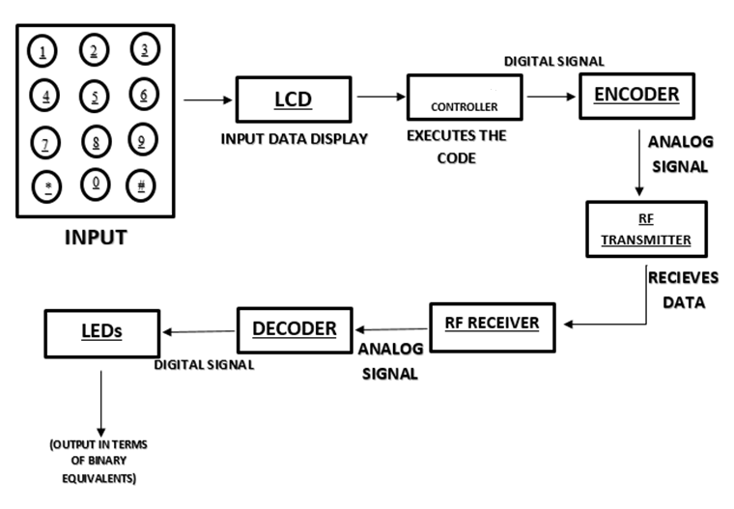

**Schematic Diagram:**

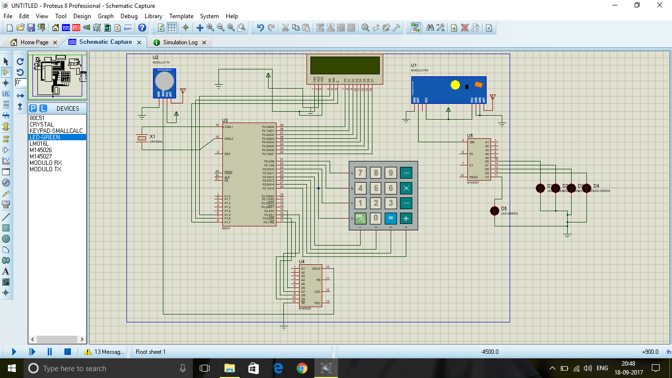

**Project Description:**

* Basically, the main aim of the project is to transmit the data wirelessly.
* So, we give the input data from keyboard which is in interface with LCD display.
* The given input through keyboard is displayed in LCD. It displays whether data is transmitting or not.
* The input data through keyboard is being passed to micro controller.
* The code is being executed in the micro controller and the output is passed to Encoder.
* The Encoder encodes the digital output to analog form.
* This analog data signal is passed to RF transmitter.
* This data signal is received by RF module, which contains Decoder IC and LEDs.
* Decoder decodes the analog form of data signal to digital form.
* This digital data output signal can be shown with the help of LEDs in terms of its binary equivalent.

**Flow chart:**

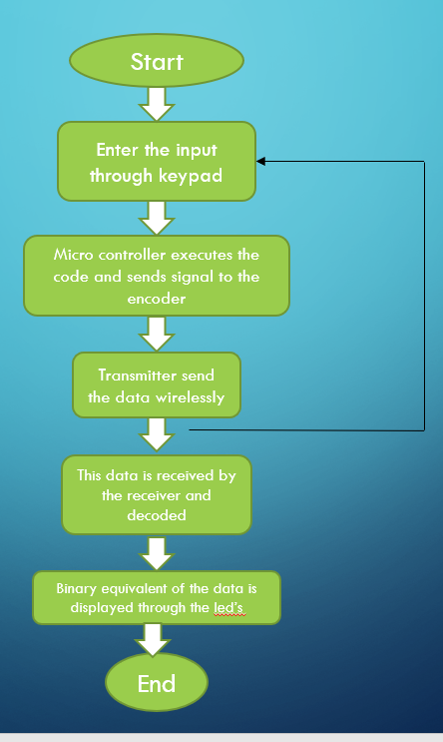

**Program:**

#include<reg51.h>

#include<intrins.h> // header file used for generating code for routine programs //

#define lcd P0 // defining the LCD DATA pins to port'0' //

sbitrs=P1^5; // DATA/COMMAND control pin of LCD assigning to Port'1.5'//

sbitrw=P1^6; // READ/WRITE control pin of LCD assigning to port'1.6'//

sbiten=P1^7; // ENABLE control pin of LCD assigning to port'1.7'//

sbitlcd_bsy=P0^7; // assigning the Port'0.7' for checking the busy of LCD//

sbit R0 = P2^7; // KEYPAD ROW1 //

sbit R1 = P2^6; // KEYPAD ROW2 //

sbit R2 = P2^5; // KEYPAD ROW3 //

sbit R3 = P2^4; // KEYPAD ROW4 //

sbit C3 = P2^3;

sbit C2 = P2^2;

sbit C1 = P2^1;

sbit C0 = P2^0;

void init_lcd(void);

void cmd_lcd(unsigned char); // LCD COMMAND write function(global declaration) //

void lcd_data(unsigned char); // LCD DATA write function(global declaration) //

void display_lcd(unsigned char *); // LCD DISPLAY function(global declaration) //

void LCD_Busy_Chk(void);

void DELAYMS(unsigned int); // DELAY function(global declaration) //

void KEYPAD(void); // KEYPAD WRITTING function(global declaration) //

void LCD_STORE(void); // KEYPAD DATA storing function(global declaration) //

int keypress(); // KEYPAD KEY PRESS checking function(global declaration) //

int i,j,k,row,col;

unsigned char key_cnt=0;

char a[4]={'0','0','0','0'};

unsigned char fkey,byte,key_store;

unsigned char KEY_PAD[4][4]={'*','0','#','D',

'7','8','9','C',

'4','5','6','B',

'1','2','3','A'};

/****************************/

/***************************/

void main(void)

{

P3=0x00;

init_lcd(); // GIVING INITIAL COMMANDS TO LCD//

cmd_lcd(0x80);

display_lcd(" RF TRANSMITTER ");

DELAYMS(1000);

Start:

cmd_lcd(0x01);

cmd_lcd(0x80);

display_lcd("ENTER ANY KEY...");

cmd_lcd(0xC0);

key_cnt=0;

while(key_cnt!=1)

{

KEYPAD();

if(fkey==1)

{

fkey=0;

a[j] = key_store;

byte=a[j];

lcd_data(byte);

key_cnt++;

}

}

DELAYMS(300);

cmd_lcd(0x01);

cmd_lcd(0x80);

display_lcd(" TX IN PROGRESS ");

DELAYMS(200);

if(byte=='1')

{

P3=0x10;

}

else if(byte=='2')

{

P3=0x20;

}

else if(byte=='3')

{

P3=0x30;

}

else if(byte=='4')

{

P3=0x40;

}

else if(byte=='5')

{

P3=0x50;

}

else if(byte=='6')

{

P3=0x60;

}

else if(byte=='7')

{

P3=0x70;

}

else if(byte=='8')

{

P3=0x80;

}

else if(byte=='9')

{

P3=0x90;

}

else if(byte=='A')

{

P3=0xA0;

}

else if(byte=='B')

{

P3=0xB0;

}

else if(byte=='C')

{

P3=0xC0;

}

else if(byte=='D')

{

P3=0xD0;

}

else if(byte=='*')

{

P3=0xE0;

}

else if(byte=='#')

{

P3=0xF0;

}

cmd_lcd(0x01);

cmd_lcd(0x80);

display_lcd("DATA TRANSMITTED");

DELAYMS(300);

cmd_lcd(0x01);

cmd_lcd(0x80);

display_lcd(" THANK YOU ");

DELAYMS(200);

goto Start;

}

/*........lcd string display................*/

void init_lcd(void)

{

cmd_lcd(0x30);

cmd_lcd(0x30);

cmd_lcd(0x38);

cmd_lcd(0x0c);

cmd_lcd(0x06);

cmd_lcd(0x01);

DELAYMS(10);

}

void cmd_lcd(unsigned char c)

{

LCD_Busy_Chk();

lcd=c;

rs=0;

rw=0;

en=1;

_nop_();

en=0;

}

void lcd_data(unsigned char c)

{

LCD_Busy_Chk();

lcd=c;

rs=1;

rw=0;

en=1;

_nop_();

en=0;

}

void LCD_Busy_Chk(void)

{

lcd_bsy=1;

rs=0;

rw=1;

while(lcd_bsy==1)

{

en=0;

_nop_();

_nop_();

_nop_();

_nop_();

en=1;

}

}

void display_lcd(unsigned char *s)

{

while(*s)

lcd_data(*s++);

}

/*...........delay routine program...........*/

void DELAYMS(unsigned int itime)

{

unsigned int x,y;

for(x=0;x<itime;x++)

for(y=0;y<1275;y++);

}

/*..........keypad display routine...........*/

void KEYPAD(void)

{

P2 = 0x0F;

if(keypress())

{

switch(P2)

{

case 0x07:col=0;break;

case 0x0B:col=1;break;

case 0x0D:col=2;break;

case 0x0E:col=3;break;

}

P2 = 0xF0;

switch(P2)

{

case 0x70:row=3;break;

case 0xB0:row=2;break;

case 0xD0:row=1;break;

case 0xE0:row=0;break;

}

key_store=(KEY_PAD[col][row]);

fkey=1;

P2 = 0x0F;

}

DELAYMS(50);

}

int keypress()

{

R0=R1=R2=R3=0;

if(C0&C1&C2&C3)

return 0;

else

return 1;

}

**Implementation Output:**

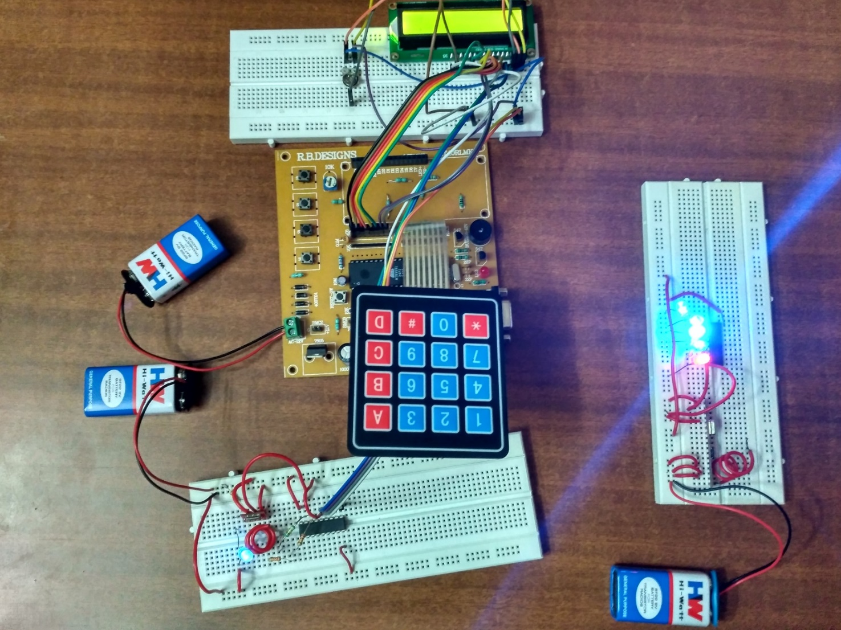

**Conclusion:**

* Since it being wireless data transmitter we are using keypad to transmit the data,in future we can replace this keypad by any electronic gadget which is helpful in transmitting data wirelessley.
* So this project has future scope which is helpful in transmitting data wirelessley.

**Concepts Learned:**

* We learnt the configuration of ports of 8051 microcontroller.
* We learnt how to interface the LCD display and Keypad to the microcontroller.
* We learnt how to code and simulate the microcontroller circuit in Proteus software.
* We learnt how to burn the code into a microcontroller.
* We learnt how to use 8051 microcontroller in our project Wireless Data Transmitter.

**Applications:**

* Any data or information can be transmitted faster with a high speed.
* Internet can be accessed from anywhere wirelessly.
* It involves security systems, television remote control,

cellphones, Wi-Fi, wireless power transfer.

* It is very helpful for workers, doctors working in remote areas as they can be in touch with medical centers.

**Difficulties faced:**

* We had difficulties while getting 8051 microcontroller Development board.
* We faced difficulties while assembling the components of our project in the proteus and simulating it.
* We had difficulties while burning the code into the microcontroller.
* We faced difficulties while assembling our project in Hardware.

**Timeline:**

* **REVIEW 0:** Choosing a Topic and analyze on it.
* **REVIEW 1:** Simulating the circuit using Proteus software.
* **REVIEW 2:** Connecting the components.
* **REVIEW 3:** Presenting the working model with the output